Data Communication And Networking

Date: 12.02.21

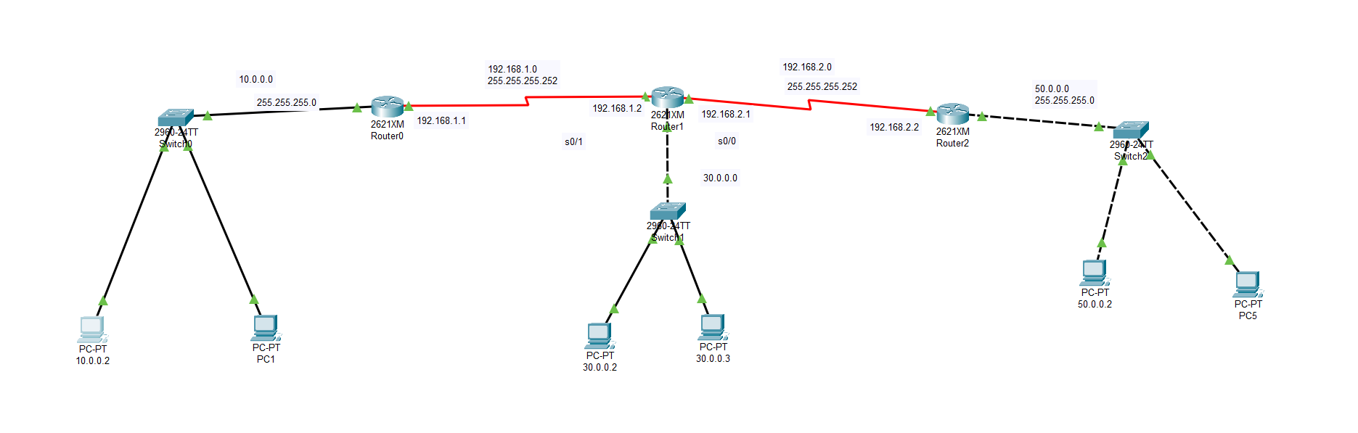Task-> Connect 3 routers with end devices

Devices Required:

Router0, Router1, Router2

Switch0,Switch1,Swtich2

End devices -> Pcs

**Configuration Router 0:**

1.) Connect Router0 with switch0 and connect swtich0 with pcs

2.) Now in CLI of Router0 configure ip for switch

Commands:>

En

conf t -> configuration mode

int f0/0

ip add 10.0.0.1 255.255.255.0

no shut ->state up

exit

3.) Connect Router0’s WIC-1T port to Router1’s WIC- T1 port through ‘Serial cable’

4.) Now Set ip for Serial 0/0 in router0

Commands:

int s0/0

clock rate 128000

ip add 192.168.1.2 255.255.255.252

no shut

**Configuration Router 1:**

1.) Connect Router1 with switch1 and connect swtich1 with pcs

2.) Now in CLI of Router1 configure ip for switch

Commands:>

En

conf t -> configuration mode

int f0/0

ip add 30.0.0.1 255.255.255.0

no shut ->state up

exit

3.) Connect Router1’s WIC-1T port to Router1’s WIC- T1 port through ‘Serial cable’

4.) Now Set ip for Serial 0/0 in router1

Commands:

int s0/0

ip add 192.168.1.2 255.255.255.252

no shut

5.) Now add another port WIC-1T and connect it to Router2 through Serial Cable

6.) Now Set ip for Serial 0/1 in router1

Commands:

int s0/1

clock rate 128000

ip add 192.168.2.1 255.255.255.252

no shut

**Configuration Router 2:**

1.) Connect Router2 with switch2 and connect swtich2 with pcs

2.) Now in CLI of Router2 configure ip for switch

Commands:>

En

conf t -> configuration mode

int f0/0

ip add 50.0.0.1 255.255.255.0

no shut ->state up

exit

3.) Connect Router2’s WIC-1T port to Router1’s WIC- T1 port through ‘Serial cable’

4.) Now Set ip for Serial 0/0 in router2

Commands:

int s0/0

ip add 192.168.2.2 255.255.255.252

no shut

**Configure Routers: Route ips of networks**

**Configure Router0:**

Commands:

en

conf t

ip route 30.0.0.0 255.255.255.0 192.168.1.2

**Configure Router1:**

Commands:

en

conf t

ip route 10.0.0.0 255.255.255.0 192.168.1.1

ip route 50.0.0.0 255.255.255.0 192.168.2.2

**Configure Router0:**

Commands:

en

conf t

ip route 30.0.0.0 255.255.255.0 192.168.2.1

ip route 10.0.0.0 255.255.255.0 192.168.2.1

**Configure Pcs: ips subnet mask and Default gateway**

**Configure Router0’s pcs:**

**Set ip 10.0.0.(2) for pc1 and 10.0.0.(number of device)**

**Subnet Mask : 255.255.0**

**Default Gateway : 10.0.0.1**

**Configure Router2’s pcs:**

**Set ip 30.0.0.(2) for pc1 and 30.0.0.(number of device)**

**Subnet Mask : 255.255.0**

**Default Gateway : 30.0.0.1**

**Configure Router2’s pcs:**

**Set ip 50.0.0.(2) for pc1 and 50.0.0.(number of device)**

**Subnet Mask : 255.255.0**

**Default Gateway : 50.0.0.1**

**Now Test network through ping command**

**Test-> from Router1’s pc Ping Router2’s pc**

**Commands:**

**Ping 50.0.0.2**

